# Group Assignment 1 - Group Lab Activity 1

TNE10006/TNE60006 S1 2022

**Assignment Weight:**   
5%

**Assignment Points:**   
50

**Submission Due Date:**

By the start of Lab Session Week 5.

**Reference Material:**

* Lab SU-5a Configuring Per-Interface Inter-VLAN Routing
* Lab SU-5b – Configuring 802.1Q Trunk-Based Inter-VLAN Routing

**Instructions:**

1. Form a group of 3-4 people amongst the students present in the lab session
2. Your group discussion time will be in the last 20 minutes of the lab session in Collaborate Ultra, Breakout groups.
3. Discuss and answer the questions in Group Assignment 1 in your breakout group.
4. Organise for your group to meet again to complete all the questions.
5. Each group will submit one completed Group Assignment 1
6. Submit Group Assignment 1, in the Canvas shell, under the Group Lab Activity 1
7. Late penalties will apply for submission after the due date.

**Group Assignment 1 Questions:**

* Section 1: Lab SU-5a Configuring Per-Interface Inter-VLAN Routing (15 marks)
* Section 2: Lab SU-5b – Configuring 802.1Q Trunk-Based Inter-VLAN Routing (9 marks)
* Section 3: Reflection on Labs SU-5a and SU-5b(26 marks)

**Group Assignment 1:**

|  |  |
| --- | --- |
| **Group Members** | |
| **Name** | **Student Id:** |
| **Dang Vi Luan** | **103802759** |
| **Nguyen Trung Hieu** | **103488337** |
|  |  |
|  |  |

**Section 1: Lab SU-5a Connectivity Scenarios (15 marks)**

Q1. After completing steps 1 – 3 in **Part 2 Configure Switches with VLANs and Trunking of Lab SU-5a**

* + 1. **Did S3 and S4 ping each other? Yes/No? If yes, explain why? If no, explain why not.  
       (1 mark)**

Yes, the two Switches share the same logical interface, which is VLAN 10, and they also have a trunk port enabled in between. Therefore, the connection between S3 and S4 is possible.

It is noteworthy that the two devices can ping each other as long as they are in the same network and have their own default gateway. The trunk port is a supplement to our topology to enable inter-VLAN routing later on. This can be demonstrated with the following pictures.

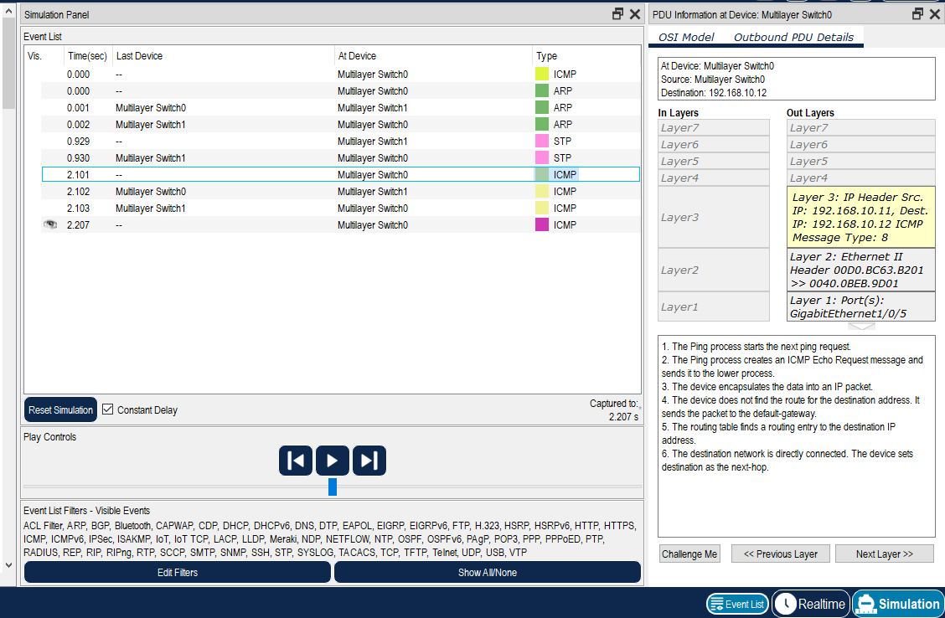

*Picture 1: ICMP between S3 and S4 without trunk*

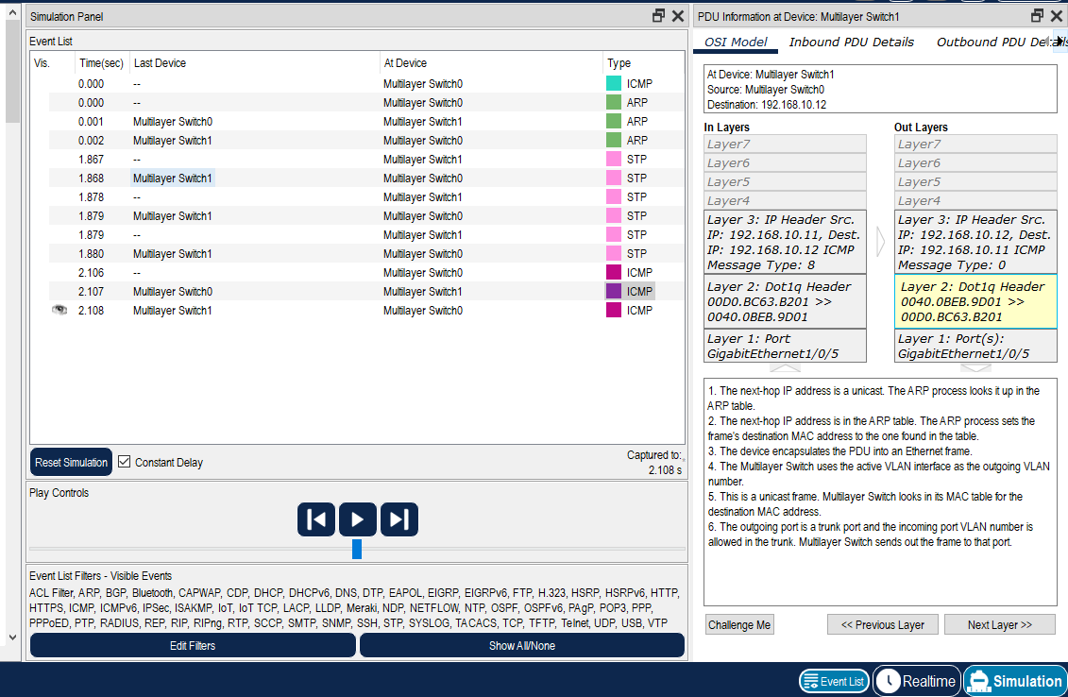

*Picture 2: ICMP between S3 and S4 with trunk*

As we can see, without a trunk port, the ICMP between S3 and S4 can also be delivered. However, the Ethernet Header of trunkless connection does not contain VLAN ID. The connection between S3 and S4 when trunk port is activated, on the other hand, contain Dot1q header, which is the VLAN information stored in Ethernet Frame.

* + 1. **Would S3 ping PC-A? Yes/No? If yes, explain why? If no, explain why not  
       (1 mark)**

Yes, S3 would be able to ping PC-A. This happens because of two reasons:

+ VLAN 10 is assigned with the IP address for the switch (192.168.10.11) and the port that connect PC-A with S3, which is Gi1/0/7, is also assigned to VLAN 10.

+ PC-A has the IP address and default gateway that shares the same network with S3.

A noteworthy point is that when we assign an IP address to a Layer 3 switch via VLAN, the connection can only be established when the connected port between two devices is also assigned to the same VLAN.

* + 1. **Would S3 ping PC-B? Yes/No? If yes, explain why? If no explain why not   
       (1 mark)**

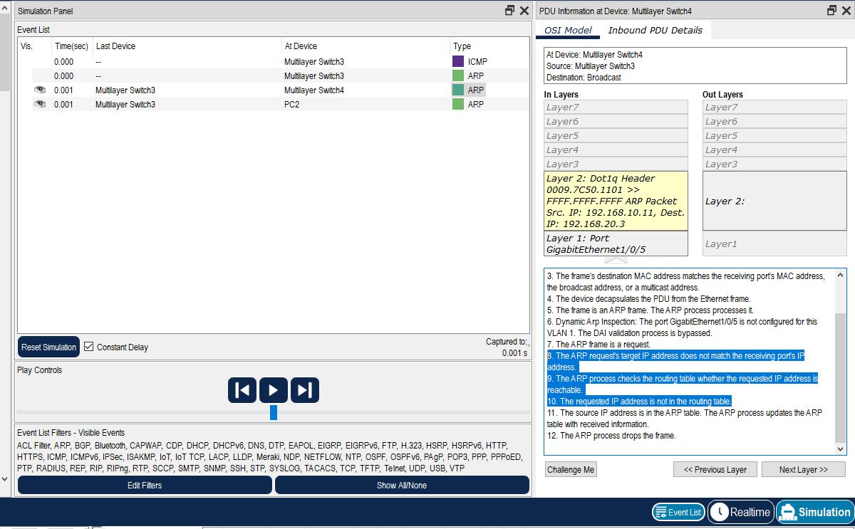No, S3 would not be able to ping PC-B, as they are not in the same network and the router has not been configured to allow routing to different network. This can be illustrated further with this picture:

*Picture 3: Connection with device in different network*

Before ICMP is attempted, S3 has yet to know the MAC address of PC-B, therefore, it sends out an ARP request for PC-B’s MAC address. However, as PC-B is in a different network and the ARP request is dropped when it reaches S4.

* + 1. **Would S4 ping PC-A? Yes/No? If yes, explain why? If no, explain why not  
       (1 mark)**

Yes, S4 would be able to ping PC-A. As they are in the same network and connected through S3.

* + 1. **Would PC-A ping PC-B? Yes/No? If yes, explain why? If no explain why not  
       (1 mark)**

No, PC-A would not be able to ping PC-B, the reason is the same as the case of S3 and PC-B that they are not in the same network and router has not been configured to allow routing to different network.

Q2. After completing Step 3 in **Part 3: Basic Router Configuration** **of Lab SU-5a**

* + 1. **How many directly connected networks (C) were there in R1’s routing table? If any, list them.   
       (2 marks)**

There are 2 networks directly connected to R1. They are 192.168.10.0/24 and 192.168.20.0/24.

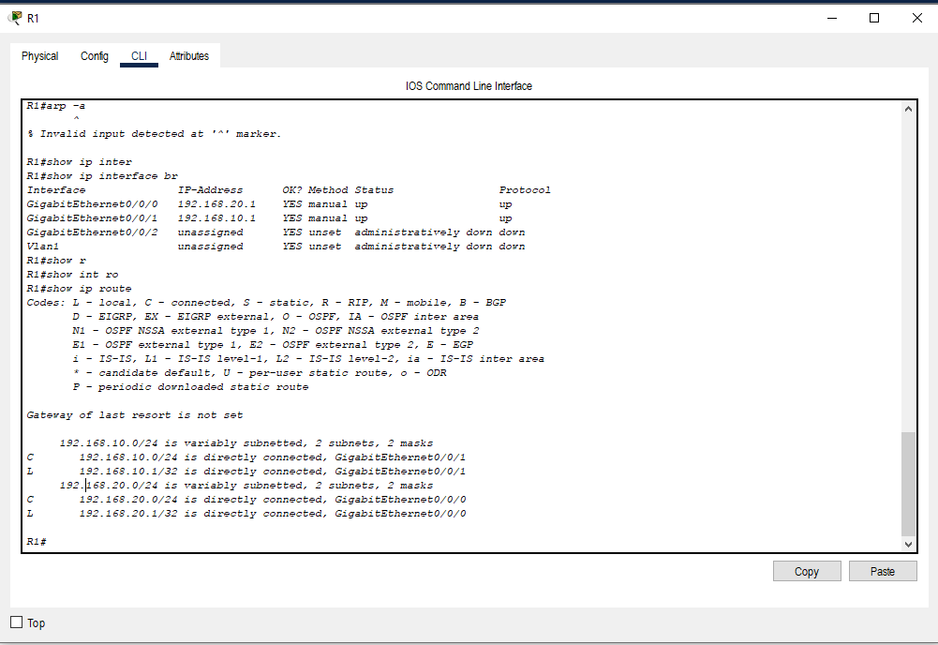This can be shown in R1 routing table.

*Picture 4: R1’s Routing table*

* + 1. **Would all devices now be able to ping each other? Give reasons for your answer.   
       (2 marks)**

All devices could now ping each other. The connection between PC-A, S3 ,and S4 has been discussed above, therefore, the explanation for it stay the same. However, with the router has now been configured, the connection between PC-A, S3,and S4 to PC-B is also possible.

Previously, when the router was not configured, the ARP Request from devices could not reach PC-B as the switch did not know what to do with IP address from different network. However, when the router is configured, the line of connection between any other devices to PC-B can be established through the router.

The router can facilitate connection to different network by using Routing Table (a table of IP address and its corresponding port) and ARP Table (a table of IP address and its corresponding MAC address). Therefore, the router can construct Layer 2 header to the recipient and in this case the switch will only need to forward the packet constructed by router.

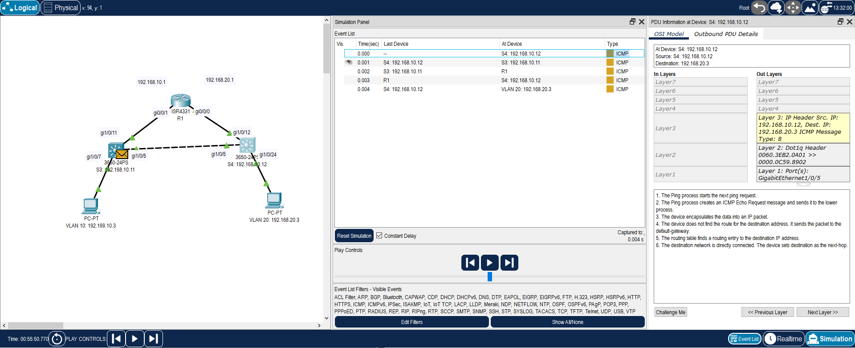Therefore, PC-A, S3, and S4 can now ping PC-B through R1. It is also noteworthy that although S4 is connected to PC-B through Gi1/0/24, the line of connection between these two devices also needs to travel through the router before it is established. The picture below will illustrate this:

Picture 5: Connection between S4 and PC-B

As we can see, the data frame from S4 has to travel to S3, R1 and from R1 to S4 again before it can be forwarded to PC-B. Although S4 is a Layer 3 Switch that has the capabilities to route data to different network via VLAN, we have yet to configured it that way. Therefore, the data frame from S4 to PC-B still need to rely on R1 to do the routing part.

* + 1. **When PC-A pings PC-B, would this traffic traverse R1? Yes/No? If yes, explain why. If no, explain why not.  
       (1 mark)**

Absolutely, PC-A and PC-B are not in the same network, therefore, routing needs to be done to established a connection between these two devices. The same can be said to the connection between our PC to the internet, our PC needs the router to translate private IP to public IP so that it can connect with hosts in different network.

* + 1. **When PC-A pings S3, would this traffic traverse R1? Yes/No? If yes, explain why. If no, explain why not.**  
       (1 mark)

No, PC-A and S3 are in the same VLAN or in other words, they are in the same network. Connection between devices in the same network can be facilitated by the switch, so in this case the traffic from PC-A to S3 would not need to be rerouted through the router.

Q3. If you shutdown port Gi0/0/1 on R1:

* + 1. **How many directly connected (C) networks would there be in R1’s routing table? If any, list them.   
       (2 marks)**

At the moment, R1 has only two directly connected networks, so if we shutdown port Gi0/0/1, which facilitates connection to VLAN 10, there would only be one remaining network. The remaining network would be 192.168.20.0/24 on port Gi0.0.0.

* + 1. **Would S3 and S4 still ping each other? Yes/No? If yes, explain why. If no, explain why not.  
       (1 mark)**

Yes, the connection between S3 and S4 does not rely on the router as they are in the same network, therefore, disabling Gi0/0/1 would not affect the connection in this case.

* + 1. **Would PC-A and PC-B still ping each other? Yes/No? If yes, explain why. If no, explain why not.**  
       (1 mark)

No, the connection between PC-A and PC-B is the connection of two different networks, therefore, a router is needed to rout the traffic. However, with Gi0/0/1 being disabled, PC-A can not connect to the router anymore and thus the connection between PC-A and PC-B is also terminated.

**Section 2: Lab SU-5b Connectivity Scenarios (9 marks)**

Q1. After completing steps 1 – 4 in **Part 2 Configure Switches with VLANs and Trunking of lab SU-5b**

* + 1. **How many directly connected (C) networks are there in R1’s routing table? If any, list them.  
       (2 marks)**

There are 4 directly connected networks in R1’s routing table including:

+ 192.168.1.0/24 on port GigabitEthernet 0/0/1.99

+ 192.168.10.0/24 on port GigabitEthernet 0/0/1.10

+ 192.168.20.0/24 on port GigabitEthernet 0/0/1.20

+ 209.165.200.0/24 on port Loopback0

* + 1. **Would S3 ping PC-A? If yes, would this traffic traverse R1?  
       (1 mark)**

Yes, S3 would be able to ping PC-A, and the traffic will traverse R1 because S3 and PC-A are in different network. Therefore, S3 will rely on R1 to do the routing before it can send data frame to PC-A.

Although S3 is a Layer 3 Switch that has the capabilities to route data to different network via VLAN, we have yet to configured it that way. Therefore, the data frame from S3 to PC-A still need to rely on R1 to do the routing part.

* + 1. **Would S3 ping PC-B? If yes, would this traffic traverse R1?  
       (1 mark)**

Yes, S3 would be able to ping PC-B, and the traffic will traverse R1 because S3 and PC-B are in different network. Therefore, S3 will rely on R1 to do the routing before it can send data frame to PC-B.

Although S3 is a Layer 3 Switch that has the capabilities to route data to different network via VLAN, we have yet to configured it that way. Therefore, the data frame from S3 to PC-B still need to rely on R1 to do the routing part.

* + 1. **Would S4 ping PC-A? If yes, would this traffic traverse R1?  
       (1 mark)**

Yes, S4 would be able to ping PC-A, and the traffic will traverse R1 because S4 and PC-A are in different network. Therefore, S3 will rely on R1 to do the routing before it can send data frame to PC-A.

Although S4 is a Layer 3 Switch that has the capabilities to route data to different network via VLAN, we have yet to configured it that way. Therefore, the data frame from S4 to PC-A still need to rely on R1 to do the routing part.

* + 1. **Would PC-A ping PC-B? If yes, would this traffic traverse R1?  
       (1 mark)**

Yes, PC-A would be able to ping PC-B, and the traffic will traverse R1 because PC-A and PC-B are in different network. Therefore, PC-A will rely on R1 to send the data to PC-B.

There is also one interesting point between the connection between Switch to Host via the Router and Host to Host via the Router.

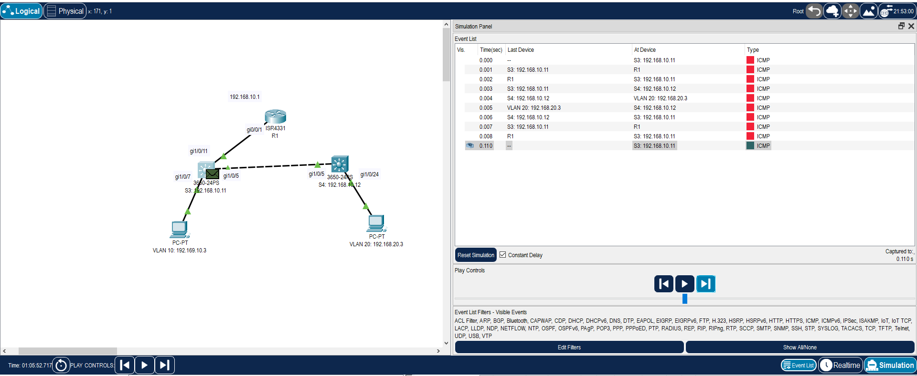A Switch relies **heavily** on the router to do the routing before it can transmit the data to designated Host. For example, when we use S3 to ping PC-B:

*Picture 6: Connection between Switch and Host*

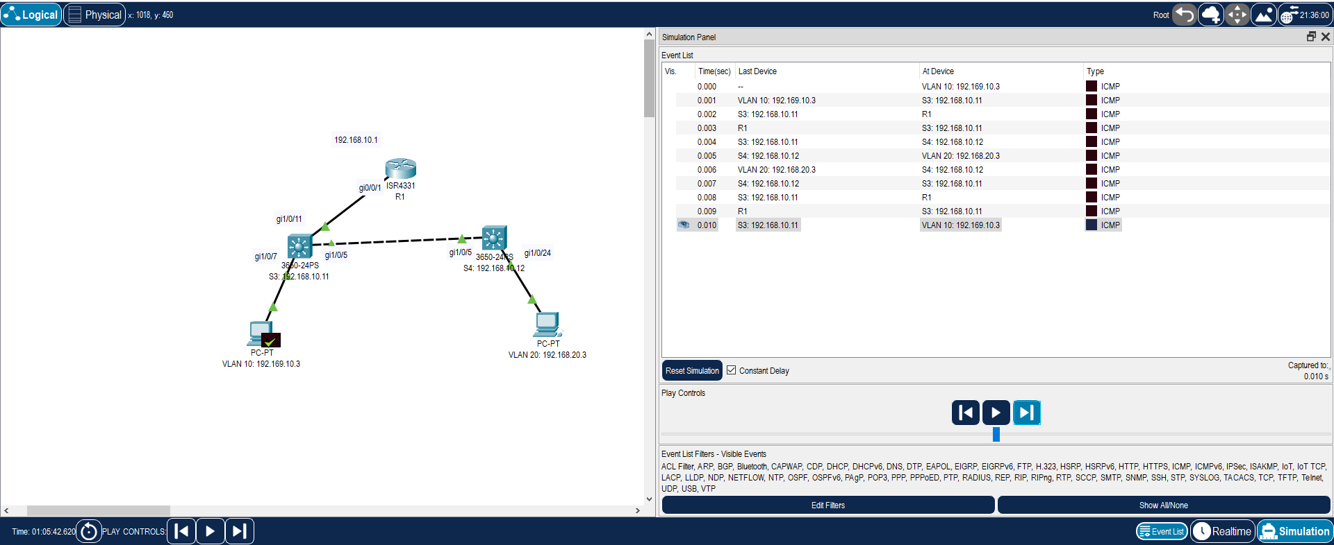A Host, however, relies **totally** on the Router and the Switch to do the routing and transmitting of data to its counterpart. For example, in this case:

*Picture 7: Connection between Host and Host*

This is because the Switch perform its functionality of forwarding the data after the Router routes it. The functionality of the Host, however, ends when it sends the data frame to the Router and the rest will be in the hand of the Switch and Router to deliver the data to the designated recipient.

* + 1. **What was the purpose of pinging S3 and S4 using the *source* option from R1?  
       (1 mark)**

The ping command determines whether a destination is reachable. Therefore, when we ping S3 and S4 using the source option, we can make sure that the sub interface that we configured are working properly. It is also an indication that inter-VLAN routing is enabled.

Q2. If you shutdown port Gi0/0/1 on R1,

* + 1. **How many directly connected (C) networks would there be in R1’s routing table? If any, list them.   
       (2 marks)**

Port GigabitEthernet 0/0/1 facilitates traffic for 3 sub interfaces including:

+ 192.168.1.0/24 on port GigabitEthernet 0/0/1.99

+ 192.168.10.0/24 on port GigabitEthernet 0/0/1.10

+ 192.168.20.0/24 on port GigabitEthernet 0/0/1.20

Therefore, if we shutdown this port, there will only be one network that is not affected which is 208.165.200.255/27 on port lo0 as it is on a different virtual interface.

**Section 3: Reflection on Labs SU-5a and SU-5b (26 marks)**

**In this section you will need to reflect on what you have learned and apply that knowledge**

Q1. Answer the following questions regarding IP settings on layer 2 switches.

* + 1. **On a layer 2 switch, what is the purpose of creating an interface VLAN and allocating and IP address to it?  
       (2 marks)**

Layer 2 Switch that has ports configured as Layer 2 can’t be given an IP address, instead we use SVI (Switched Virtual Interface) to assign an IP address to a switch, the main purpose of doing that is to enable remote access to the switch to manage it. By default, VLAN 1 is the management interface for remote access (Telnet or SSH). However, remote access through the network requires a valid IP address configured for VLAN.

* + 1. **On a layer 2 switch, what is the purpose of configuring a default gateway?   
       (2 marks)**

The default gateway on a switch enables traffic to be sent from its network to another network. As when a Switch receives data frame with an foreign IP address, it will forward the frame to the default gateway (usually this gateway is connected to a Router). Therefore, without a default gateway, we won’t be able to send traffic to network outside of our own.

* + 1. **Based on what you learned on labs SU-5a and SU-5b, which IP address should be configured as the default gateway IP on layer 2 switches?**   
       (2 marks)

As said above, the Switch will forward data frame with a foreign IP address to its default gateway, hence, the default gateway should be connected to a device that can route the data frame to its designated recipient. As a result, the default gateway of a Switch is usually the router the switch is connected to.

Q2. Answer the following questions regarding inter-vlan routing configuration.

* + 1. **In labs SU-5a and SU-5b, you used two different approaches to configuring inter-vlan routing. Explain the difference(s) between the two.   
       (6 marks)**

In lab SU-5A, we use legacy inter-VLAN routing. In lab SU-5B, we used Router-on-a-stick (ROAS).

The main difference between these two approaches is that in legacy-VLAN routing, multiple router interfaces are used, and the interfaces are then connected to a corresponding switch port in different VLAN. These interfaces served as default gateways for routing in different network.

Router-on-a -stick, however, only use one physical interface port for routing traffic in different network. For this to happen, we need to divide this one physical interface port into separate sub-interfaces.

Therefore, Legacy inter-VLAN routing will costs more if we want to expand our network as we will need more cables. ROAS, however, will be more cost-efficient.

* + 1. **When configuring a router-on-a-stick topology, the link between the switch and the router must carry traffic for multiple VLANs. How is this achieved on the router? How is this achieved on the switch?   
       (4 marks)**

On a Switch, we need to enable trunking on the switch port that is connected to the router.

On a router, with the trunking being enabled, the traffic between different VLAN to the Switch and to the Router will be tagged so that the router can know which VLAN the traffic belongs to. With this being done, we also need to divide the one physical interface port into separate sub-interfaces that receive traffic from its corresponding VLAN tag. By doing this, the router can now identify the traffic from each VLAN and route them to the correct recipient.

* + 1. **What are the benefits of using the “router-on-a-stick” topology for inter-vlan routing?  
       (6 marks)**

Router-on-a-stick allows one physical interface between the Router and the Switch to be divided into several sub-interfaces, these sub-interfaces can receive traffic from a specific VLAN that we configure. By doing this, we will need fewer physical cables, and in some cases we might as well reduce the number of router that need to be used. With that being done, we can reduce the costs for constructing our network. Furthermore, Voice and data traffic are on separate sub-interface and thus are on separate VLANs.

* + 1. **Are there any disadvantages to using “router-on-a-stick” inter-vlan routing as compared to the per-interface approach?   
       (2 marks)**

There are some disadvantages when we use ROAS:

+ It would be more complex to set up.

+ Traffic between VLANS might need to travel through Router many times and they are transmit through the same port. Therefore, there might be some source of congestion.

* + 1. **Other than directly connected (C) networks, did you observe any other type of networks in R1’s routing table? If yes, specify what type of networks were there and what do they represent.  
       (2 marks)**

Apart from directly connected networks, such as those which have the subnet mask of /24, there are also /32 networks. /32 means that there is only one IPv4 address, these are the local network, and they represent each sub-interfaces that we have configured.